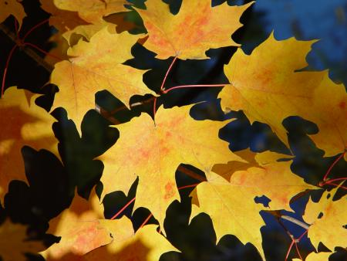
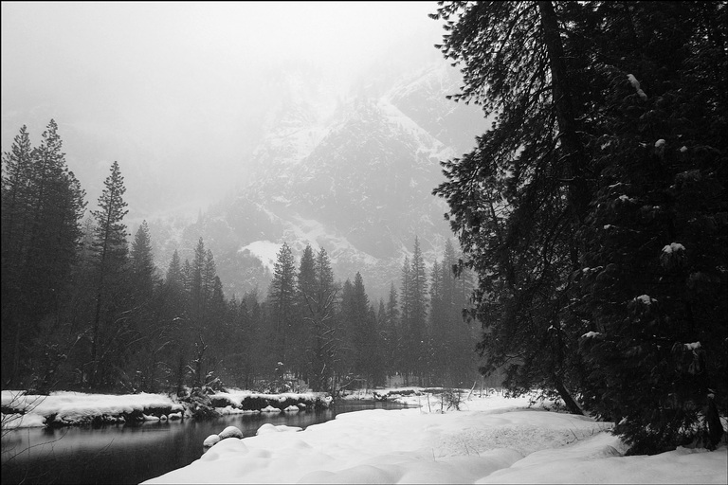


Christmas Concert
Choir Schedule
Fall/Winter 2010

Thursday, September 16 Regular Rehearsal, Room 14, 7:00 – 8:45 p.m.

Thursday, September 23 Regular Rehearsal, Room 14, 7:00 – 8:45 p.m.

Thursday, September 30 Regular Rehearsal, Room 14, 7:00 – 8:45 p.m.

Thursday, October 7 Regular Rehearsal, Room 14, 7:00 – 8:45 p.m.

Thursday, October 14 Regular Rehearsal, Room 14, 7:00 – 8:45 p.m.

Thursday, October 21 NO REHEARSAL – EDUCATION MN (MEA)

Thursday, October 28 Regular Rehearsal, Room 14, 7:00 – 8:45 p.m.

Thursday, November 4 Regular Rehearsal, Room 14, 7:00 – 8:45 p.m.

Thursday, November 11 Regular Rehearsal, Room 14, 7:00 – 8:45 p.m.

Thursday, November 18 Regular Rehearsal, Room 14, 7:00 – 8:45 p.m.

Thursday, November 25 NO REHEARSAL, HAPPY THANKSGIVING!

Thursday, December 2 Regular Rehearsal, Room 14, 7:00 – 8:45 p.m.

Wednesday, December 9 Regular Rehearsal, Room 14, 7:00 – 8:45 p.m.

Thursday, December 14 MANDATORY DRESS REHEARSAL, 4:30 – 7:30p.m.

Saturday, December 18 1:00p.m. call for a 2:00p.m. Performance

Saturday, December 18 6:45p.m. call for a 7:30p.m. Performance

Sunday, December 19 6:45p.m. call for a 7:30p.m. Performance

